Sunday | Monday | Tuesday | Wednesday | Thursday | Friday | Saturday
April 2023  Activity Calendar |  |  |  | 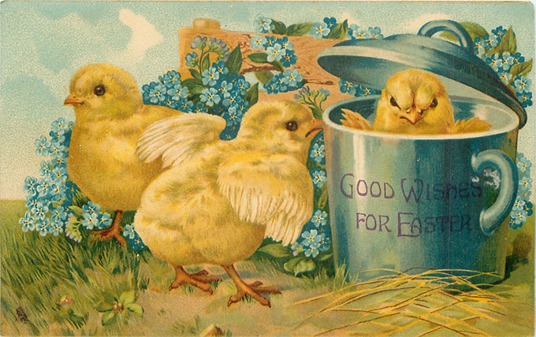 |  | 1
9:30 Fun Fitness
10:30 Snack Cart
1:00 Bingo
2:00 Snack Cart
2 | 3 | Beauty Shop Open 4 | 5 | Full Moon 6 | 7 | 8
9:30 Fun Fitness  10:30 Snack Cart  1:00 Fancy Fingers  2:00 Snack Cart | 9:30 Fun Fitness  10:30 Snack Cart  1:30 Bingo  2:30 Snack Cart | 9:30 Fun Fitness  10:30 Snack Cart  1:30 Pictionary  2:30 Snack Cart | 9:30 Fun Fitness  10:30 Snack Cart  1:30 Bingo  2:30 Snack Cart | 9:30 Fun Fitness  10:30 Snack Cart  1:30 Movie Day  3:00 Snack Cart | 9:30 Fun Fitness  10:30 Snack Cart  1:30 Easter Celebration  2:30 Snack Cart | 9:30 Fun Fitness  10:30 Snack Cart  1:00 Bingo  2:00 Snack Cart
Easter 9 | 10 | 11 | 12 | 13 | 14 | 15
9:30 Fun Fitness  10:30 Snack Cart  1:00 Fancy Fingers  2:00 Snack Cart | 9:30 Fun Fitness  10:30 Snack Cart  1:30 Bingo  2:30 Snack Cart | 9:30 Fun Fitness  10:30 Snack Cart  1:30 Live Music  2:30 Snack Cart | 9:30 Fun Fitness  10:30 Snack Cart  1:30 Bingo  2:30 Snack Cart | 9:30 Fun Fitness  10:30 Snack Cart  1:30 Movie Day  3:00 Snack Cart | 9:30 Fun Fitness  10:30 Snack Cart  1:30 Crafty Time  2:30 Snack Cart | 9:30 Fun Fitness  10:30 Snack Cart  1:00 Bingo  2:00 Snack Cart
Sue K. B-day 16 | 17 | 18 | 19 | 20 | 21 | Milo H. B-day 22
9:30 Fun Fitness  10:30 Snack Cart  1:00 Hymn Sing-a-Long  2:00 Snack Cart | 9:30 Fun Fitness  10:30 Snack Cart  1:30 Bingo  2:30 Snack Cart | 9:30 Fun Fitness  10:30 Snack Cart  1:30 Monthly Birthday Party  2:30 Snack Cart | 9:30 Fun Fitness  10:30 Snack Cart  1:30 Bingo  2:30 Snack Cart | 9:30 Fun Fitness  10:30 Snack Cart  1:30 Movie Day  3:00 Snack Cart | 9:30 Fun Fitness  10:30 Snack Cart  1:30 Earth Day Celebration  2:30 Snack Cart | 9:30 Fun Fitness  10:30 Snack Cart  1:00 Bingo  2:00 Snack Cart
23 | 24 | Nancy V. B-day 25 | 26 | 27 | Arbor Day 28 | 29
9:30 Fun Fitness  10:30 Snack Cart  1:00 Fancy Fingers  2:00 Snack Cart | 9:30 Fun Fitness  10:30 Snack Cart  1:30 Bingo  2:30 Resident Council | 9:30 Fun Fitness  10:30 Snack Cart  1:30 Tai Chi  2:30 Snack Cart | 9:30 Fun Fitness  10:30 Snack Cart  1:30 Bingo  2:30 Snack Cart | 9:30 Fun Fitness  10:30 Snack Cart  1:30 Movie Day  3:00 Snack Cart | 9:30 Fun Fitness  10:30 Snack Cart  1:30 Crafty Time  2:30 Snack Cart | 9:30 Fun Fitness  10:30 Snack Cart  1:00 Bingo  2:00 Snack Cart
30 |  |  |  | **Mail visits Monday-Saturday except holidays  **Schedule is subject to change at any time…  please watch channel 2 for most current updates  **Outside Activities = Weather permitting
9:30 Fun Fitness  10:30 Snack Cart  1:00 Hymn Sing-a-Long  2:00 Snack Cart | 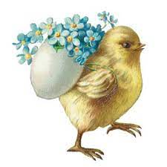 | 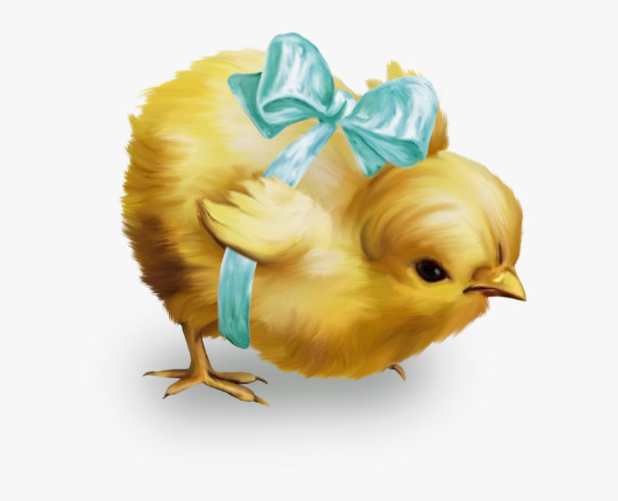 | 