March 10th – 16th 
`
..

Sunday 10th  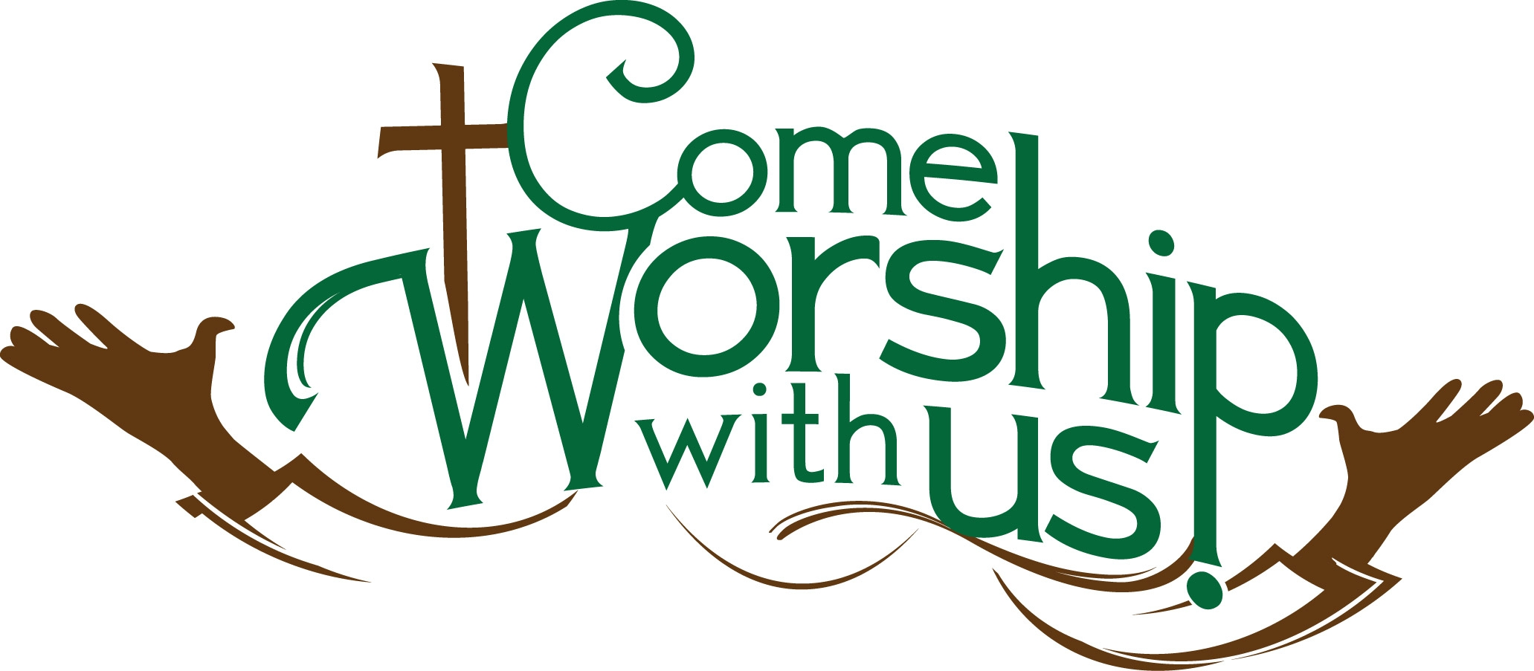 | 9:45 Move your Muscles  10:30 Lets Get Moving  2:00 Sunday Worship  - Deacon Greg Ricci- St. Anthony’s  3:00 Coffee  3:30 Room Visits – With Remembers Activities
Monday 11th  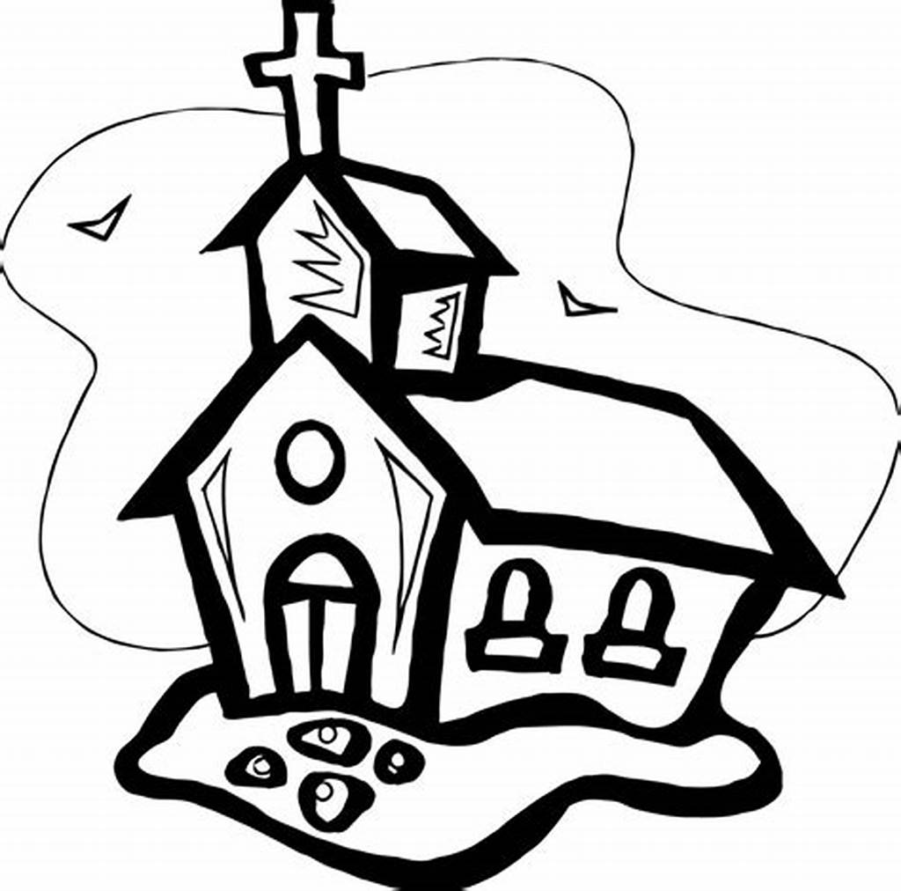 | 9:45 Move your Muscles  10:30 Kick Ball  2:00 St. Paul’s Worship  3:00 Coffee and Snacks with Friends
Tuesday 12th  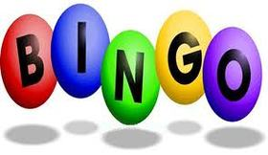 | 9:45 Move your Muscles  10:30 Let’s Get Moving  1:30  2:30 Coffee  3:30 Games / Puzzles
Wednesday 13th   | 9:45 Move your Muscles    10:30 Kick Ball  1:30 Cookies and Coffee  2:00 Reading of Cumberland  Advocate in Main Dining Room  6:00 Trivia
Thursday 14th  Rebecca Fry   | 9:45 Move your Muscles  10:30 Lets Get Moving  1:30  2:30 Coffee with Friends  3:30 Crafts will change Weekly  6:00 Brain Fun/ Word Games
Friday 15th  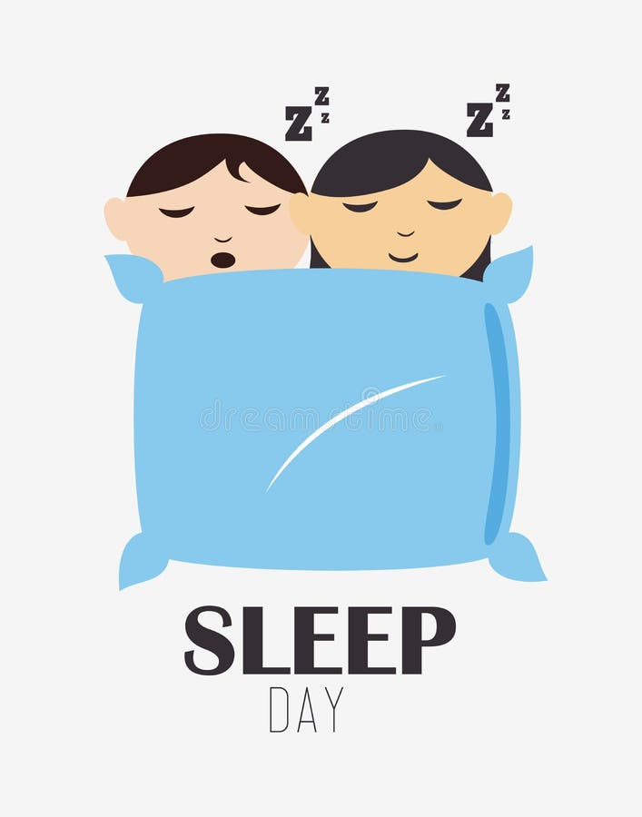 | 9:45 Move your Muscles    10:30 Kick Ball  1:30 Baking will Change Weekly  3:30 Movie Night
Saturday 16th | 9:45 Move your Muscles  10:30 Let’s Get Moving  1:30 Fancy Fingers  2:30 Coffee and Conversation  3:30 Trivia

